TOWN OF ASHLAND
ASHLAND TOWN HALL
HIGHBRIDGE, WI 54846

NOTICE IS HEREBY GIVEN that a meeting of the Board of Supervisors for the Town of Ashland, Ashland County, State of Wisconsin, for the transaction of business as is required by law or permitted to be transacted at such a meeting, will be held at the HIGHBRIDGE TOWN HALL on Tuesday, January 13, 2026, at 7pm.

The agenda is as follows:
- Call to Order
- Roll Call
- Pledge of Allegiance
- Approval of Agenda
- Introduction of Guests
- Approval of Minutes of December 2, 2025, meeting
- Treasurer’s report
- Approving vouchers and paying bills
- Old Business
- New Business
- Potential purchase of used Heavy Duty Volvo Fork (Stricker)
These forks are ideal for a wide range of lifting applications. They significantly expand the versatility and productivity of your loader.
Designed for ISO couplers, which are standardized quick-attach interfaces used on loaders and other heavy equipment.
- Cost for this used fork is $4,000 plus $250 shipping. Purchase of new fork $7,500 plus shipping at minimum.

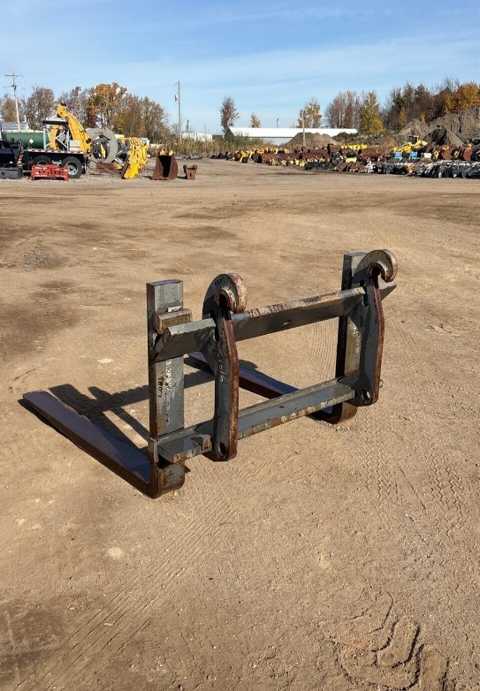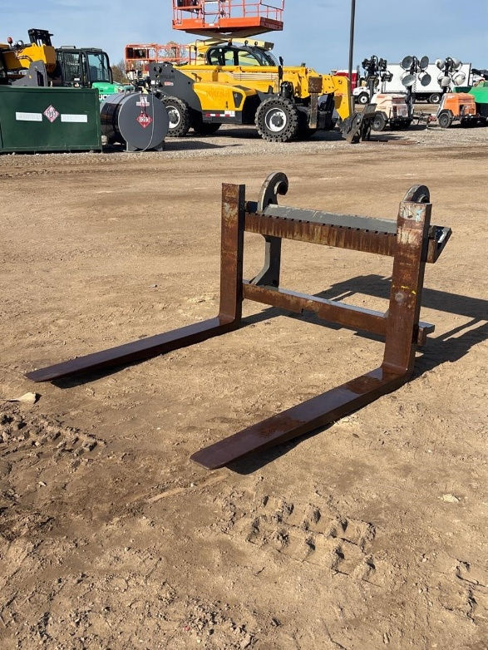

- Status Reports
- Cemetery
- Tri-M Sanitary
- Supervisor’s Report – road maintenance
- Employee Relations
- Equipment and Daily Operations
- Correspondence
- Public Comments
- Next meeting date
- Adjournment

